Mortgage Profile Builder Results Requirements

See mock-up on slide 0 of the PPT ‘Platform Mock Ups’

The input process for the Mortgage profile builder is discussed in Wireframe Feedback document. This document pertains to the output/results page, which is an interactive and dynamic tool incorporating the functionality of LoanSifter.

* As the user answers questions in the Mortgage Profile Building, the borrower profile (answers to questions) is created and displayed on the page on the far right
  + An additional, calculated metric will be Loan-to-Value with bar showing percentage as pictured in ppt. Percentage is calculated as follows:

LTV =( Loan Amount = Answer to Q4 – Answer to Q5)/ Property Value = Answer to Q4

* ‘Change answers’ button at bottom of Profile Section will allow user to change any of the answers to the input questions (our 6 MPB questions will appear on one screen with ‘update results’ button, similar to this (https://www.quickenloans.com/my-mortgage/calculator#!/purchase/results):

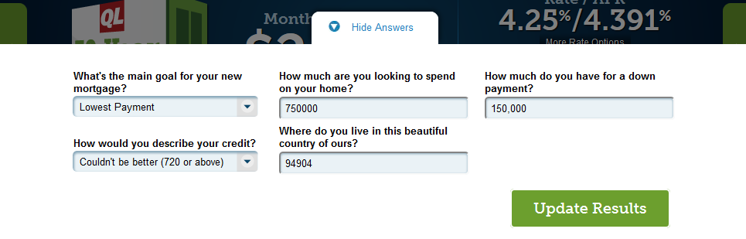

* The results section of the page will have a snapshot of the profile as well as the loansifter results
  1. Number of potential lenders
  2. Expected rates and payments
  3. Instructions on how to move forward
* In order to obtain the results (1, and 2 above), Information needs to be input into LoanSifter (see screenshow below) including
  + Price = 101.75 (keep constant)
  + For Home purchase:
    - Property Value = Answer to Q4
    - Loan Amount = Answer to Q4 – Answer to Q5
    - Zip Code = Answer to Q3
    - FICO = Answer to Q6 (take low end of range)

|  |  |
| --- | --- |
| Lock Days | leave blank |
| Loan Amount | fill from input |
| Property Value | fill from input |
| DTI | leave blank |
| FICO | fill from input |
| FICO2 | leave blank |
| Military | False? |
| Rural | False? |
| Prepayment Penalty | No PPP |
| Property Type | Single Family Detatched |
| Owner Occupied | Owner Occupied |
| Purpose Type | fill from input |
| Escrow Type | None Waived |
| Document Type | Full Doc |
| Employment Type | Wage Earner? |
| First Time Home Buyer | False? |
| Non Permanent Resident Alien | False? |
| State | look up |
| County | look up |
| Postal Code | fill from input |
| Interest Only | False? |
| Properties Owned | 1 |
| New Construction | False? |

* + For Refi
    - Define inputs
* Run and store results for the scenarios described below for the following 6 product types (they will be dynamic based on inputs)
  + - 30 year fixed
    - 15 year fixe
    - 5 year ARM
    - 7 year ARM
    - 10 Year ARM
    - FHA
* These products are listed as buttons, which, when clicked, will refresh the page and show the results for that particular product
* Results include, for one particular product
  + Number of Potential Lenders (Count unique)
  + Expected rate and payment and corresponding points(dynamic based on search results)
    - Rate:
    - Points: Express as Range: for high end of range select 10th loansifter result and for low end of range, select 1st loansift result; where the result = 101.75 – Price .
    - Payments: Return Payment for that rate
    - APR: calculated result using encompass and several inputs – more info coming
* Store results for the following scenarios, for each product
  + Scenario 1: 0 points, or closest to 0 points (as displayed in results screen)
  + Scenario 2 , 3: Rate from scenario 1 +/- 0.125 (click on applicable rate and loan pricing will update)
    - Rate = Rate(Scenario 1) + 0.125; Rate (Scenario 1)-0.125
    - Points = 101.75 – (Price from 10th result); 101.75 – (price from 1st result)
    - Payment = Payment for that rate
    - APR = Calculated field
  + Scenario 4 , 5: Rate from scenario 1 +/- 0.25 (click on applicable rate and loan pricing will update)
    - Rate = Rate(Scenario 1) + 0.25; Rate (Scenario 1)-0.25
    - Points = 101.75 – (Price from 10th result); 101.75 – (price from 1st result)
    - Payment = Payment for that rate
    - APR = Calculated field(more info coming)
* On results page Display only results for scenario 1
* Link saying ‘Show me more’ below results, which, upon clicking, displays all 5 scenarios
* Final component of the page is instructions on how to move forward: Your mortgage profile is almost complete! We need a little more information for our advisors to be able to help you find the right mortgage
  + Contact box with the following info (same as contact us)
    - First Name
    - Last Name
    - Phone
    - Email

